BLOOMINGDALE BOUROUGH BOARD OF HEALTH
REGULAR MEETING MINUTES – December 3, 2018

- Call to Order.
Ms. Petersen called the meeting to order at 7:28 p.m.

- Roll Call.
Present: Petersen, Innamorato, Carney, Tierney and Lovelace
Also Present: Gail Gratzel, Assistant Health Officer
Tim Zachok, REHS

- Approval of Minutes.
Motion was made by Ms. Carney to approve the November 5, 2018 minutes as presented. This motion was seconded by Ms. Innamorato and was unanimously approved.

- Acceptance of Reports
After discussion of the presented reports on motion by Ms. Carney with a second by Ms. Innamorato the Health Department Reports were approved as submitted and unanimously approved.

- Unfinished Business
Bloomingdale Health Center – Legionella Update: Ms. Gratzel reported that the water has been sampled again on 11/14/2018. The results should be back shortly as they usually take two weeks to receive. The chlorine pumps have been installed and were put into use 11/23/2018. Sampling will continue at the facility and results will be forward to the health department.

- New Business
Ms. Gratzel reported that she has not heard back from Walter T Bergen Principal, Frank Verducci with regards to the e-cigarette program. She will send him a follow up email. The BOH members would like Ms. Petersen, board president, to send a letter to Mr. Verducci with regards to the program. Ms. Petersen stated that she may make an appointment to see Mr. Verducci as the board believes that this topic is very important since more and more youth are vaping.
The 2019 Regional Health Budget was reviewed by the board with no comments. Ms. Gratzel stated that she is not included in this budget as she will be retiring with her last day of employment with Pequannock Township being February 28, 2019.
Ms. Petersen stated that she would like to discuss the Dementia Friendly Community initiative. Ms. Gratzel stated that she spoke with Rhonda Brand, President of the National Council for Certified Dementia Practitioners in Sparta NJ regarding this initiative. Ms. Brand stated that she would reach out to Mayor Dunleavy since she thinks that there would be a cost involved. Ms. Brand stated that this should be tabled and revisited at the January BOH meeting. She will reach out to Mayor Dunleavy prior to this meeting. Ms. Gratzel gave board members information on this initiative to review prior to the next BOH meeting. Ms. Gratzel will update Mayor Dunleavy.

- Public Discussion
Motion was made by Ms. Innamorato to open the meeting to public discussion. This motion was seconded by Ms. Tierney and all voted in favor. As there was no public wishing to address the Board, motion was made by Mr. Lovelace to close the meeting to public discussion. This motion was seconded by Ms. Tierney and all voted in favor.

- Adjournment
Motion was made by Ms. Innamorato to adjourn the meeting at 7:52 p.m. This motion was seconded by Ms. Carney and all voted in favor.

Approved:
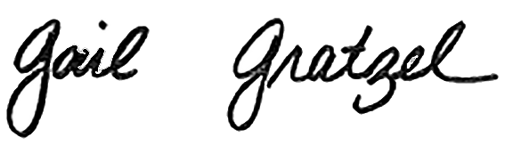
Gail Gratzel, MPH
Assistant Health Officer

